

BIS 657 Individual Project Report

Arun Kumar Reddy Challa



April 27, 2017

Central MicHigan university

Individual Project for BIS657S

Prepared by: Arun Kumar Reddy Challa Date Prepared: 25th April 2017

Status: Completed Version: 1.0

# **Functional Design:**

Stock Management System for a Medical Store.

# Open Issues:

1. The Signup page doesn’t generate a user ID automatically.
2. Anyone who can Login is authorized to view/change contents.
3. Reports are not ALV (ABAP LIST VIEWER).

# Functional Description:

Managing stock in a store is big challenge. In a medical store, there are various number of products. Employees cannot know everything like where a particular product is, within the store. So, this application keeps track of the physical location of all the products available in the store. This application can also be used in a warehouse to keep track of all the available materials.

Only an authorized person can login to the system. A first-time user needs to register with his details so that the system generates a default password. On the first login attempt, user will be prompted to change the password, using which he can login to the system anytime. Once logged on, user can view and manage the vendors currently associated with the store. Similarly, user can view and manage the products within the store and he can track the physical location of each product available. User can search for any product by its name the product search option.

# Functional Design not in scope of this document:

1. User can search for a product only using its full name.
2. Product Id and Vendor Id are not generated automatically.

# Functional Design Assumptions:

1. Physical location of all products is pre-defined.
2. Every employee who logs on is an admin.

# Technical Flow:

# List of Tables:

* ZLOGIN30
* ZUSER_DETAILS_30
* ZVENDOR30
* ZPRODUCT30.

# Credentials:

User-ID: challa

Password: challa

# Detailed Process and Design:

## Sign-in and Sign-up process:

* Use Transaction Code: ZP30 to get onto Login screen.

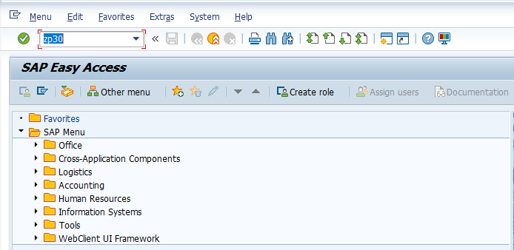

* Zp30 navigates to the following login screen

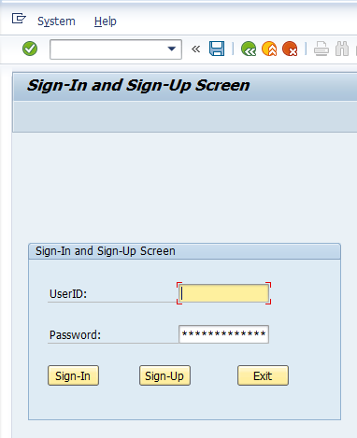

* When no login details are entered (or) wrong credentials are entered, system will ask user to signup

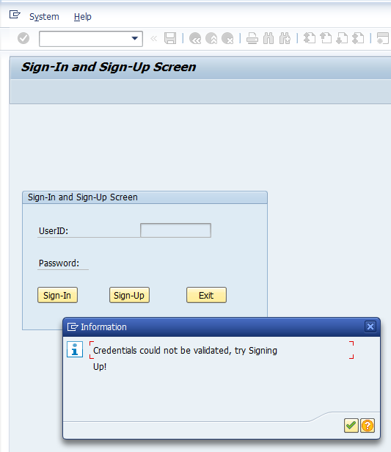

* Click on Sign-Up to get on to the registration page. This is the second screen used in this project

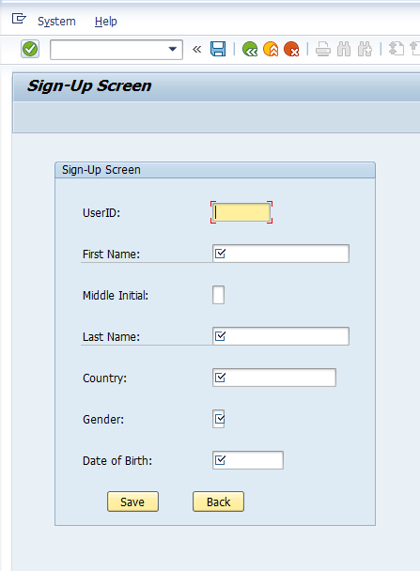

* Fill in all the fields and hit ‘Save’ button

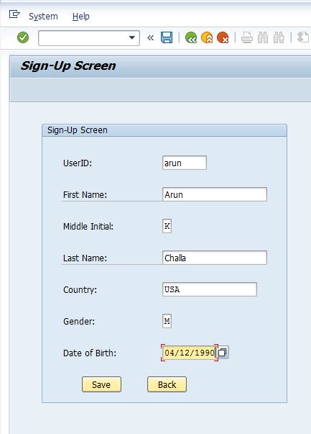

* This will insert the record into ZLOGIN30 table and system gives a confirmation message

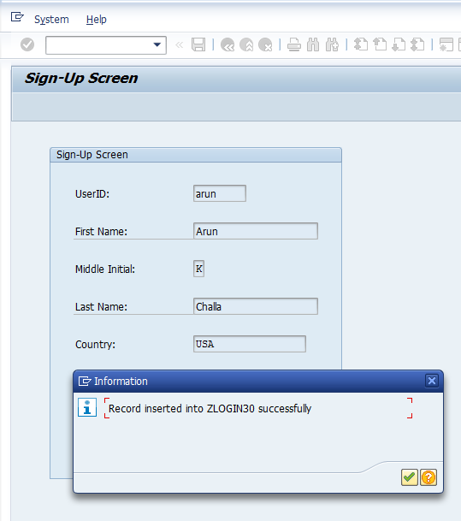

* A default password, “newPW” will be automatically assigned to the user-specified userID.
* Hit ‘Back’ button to go back to the login screen.
* Use the UserID specified, associated with the default password “newPW” to proceed further.
* Since it is first login attempt, user will be prompted to change the initial password.

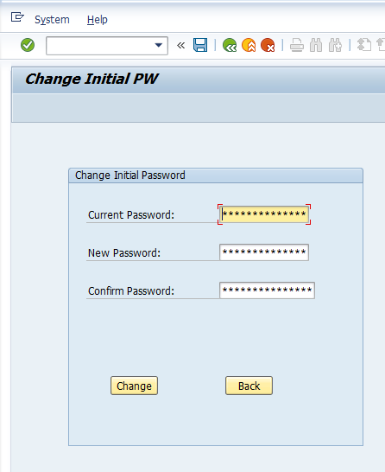

* Enter the new password that can be used further to login and hit ‘Change’ button.
* It gives the confirmation message that password is updated.

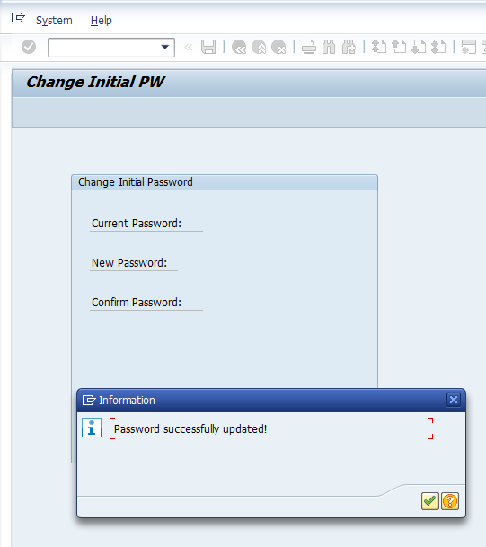

* Click ‘Back’ button to get back to the login screen.
* Now use the specified userID and Password to login to the system.
* That displays the Main Screen.

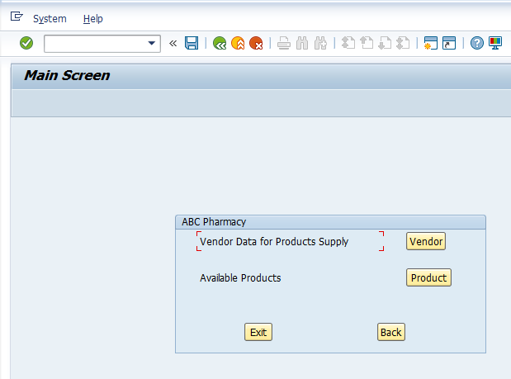

## Vendor Details:

* To display or manage the details of Vendors, click “Vendor” button.
* When “Vendor” button is clicked, the following screen is displayed.

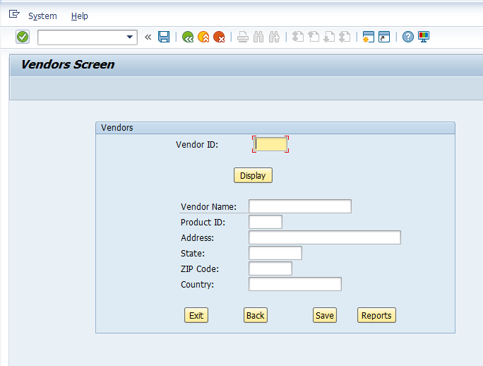

* This screen can be used to display the details of vendors by using “Vendor ID”.

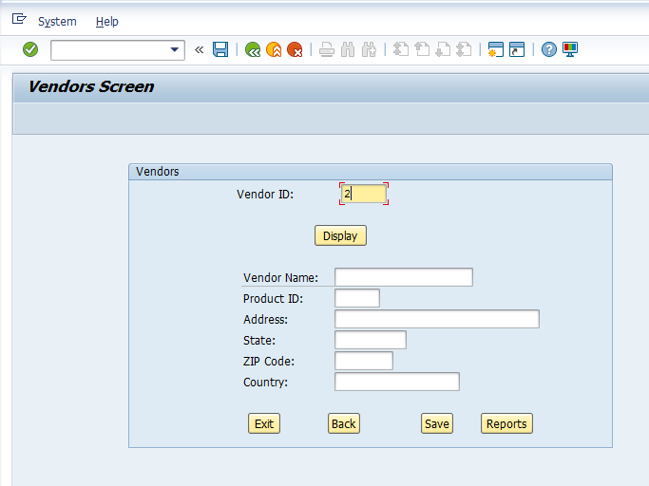

* Enter a vendor ID and click “Display” button.

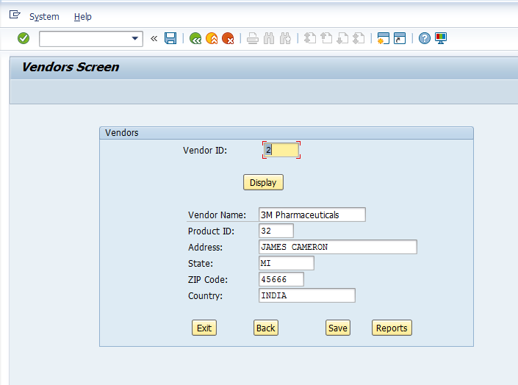

* User can edit any of these details and hit “Save”, which modifies data in the database.
* Giving an invalid ID shows up blank form.

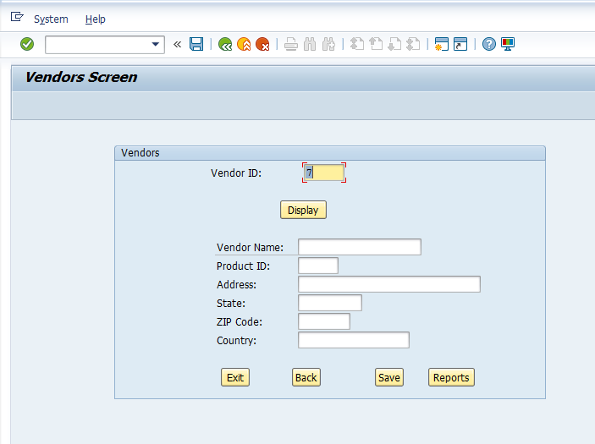

* User can now enter a new vendor into the system by filling in these fields.
* Use “Reports” button to view all the details of all available vendors.
* Below is the Vendors Report.

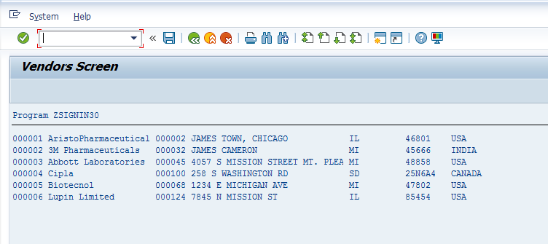

## Product Details:

* To display or manage the details of Products, click “Product” button.
* A product can be searched using “Product Name” or “Product ID”.
* When “Product” button is clicked, the following screen is displayed.

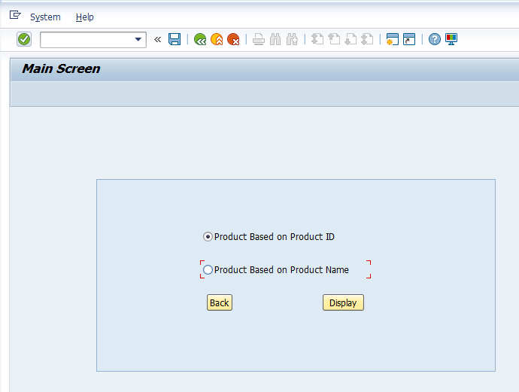

* Select the appropriate Radio button and hit “Display”.

### Product Search based on Product ID:

* Click “Product Based on Product ID” Radio button and hit “Display” button.
* The following screen appears.

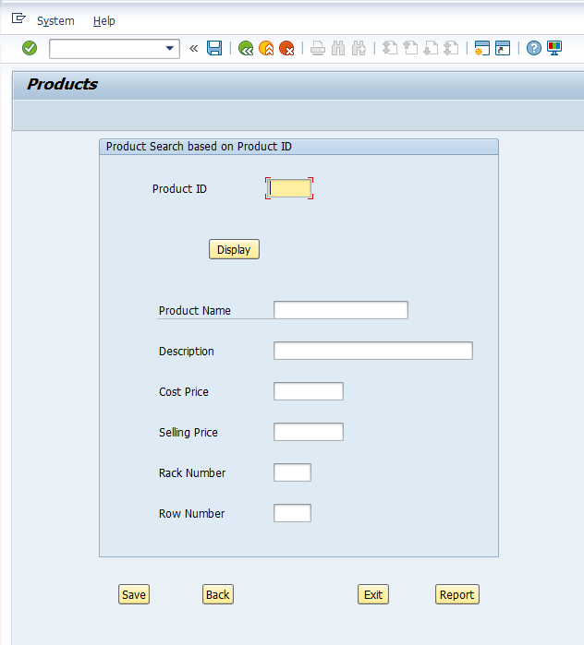

* Enter a product ID and click “Display” button which displays all the details of that particular product.
* Similar to “Vendors” screen, details of products can be modified which will be reflected in the appropriate table.

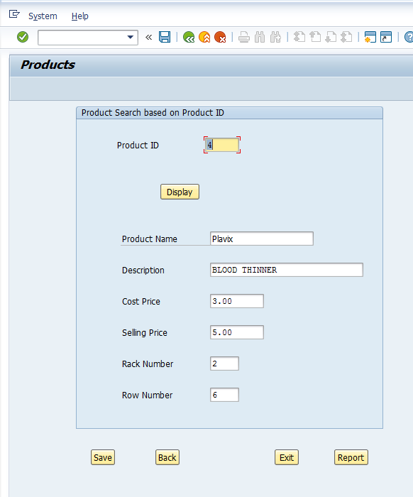

* A new product can be entered the system using the blank screen.
* Use ‘Report’ button to view all the available products in our system.

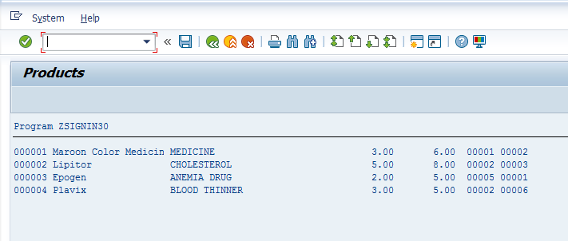

### Product Search based on Product Name:

This feature can be exclusively used within a medical store to find the physical location of a particular medicine. Since a medical store contains several products; when a customer requests a particular product, an employee can easily identify that product in the store. This feature can be extended to a large warehouse to track the location of inventory.

* Click “Product Based on Product Name” Radio button and hit “Display” button.
* The following screen appears.

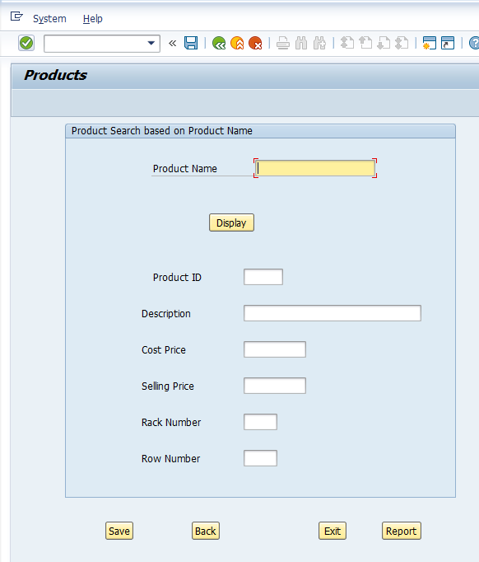

* Enter the name of product to find and hit ‘Display’, which pulls up all the fields including “Rack Number” where the product is present and which row of that rack it is present is also displayed.
* User can edit these details also. If the product is shifted to a new location, it can be updated.

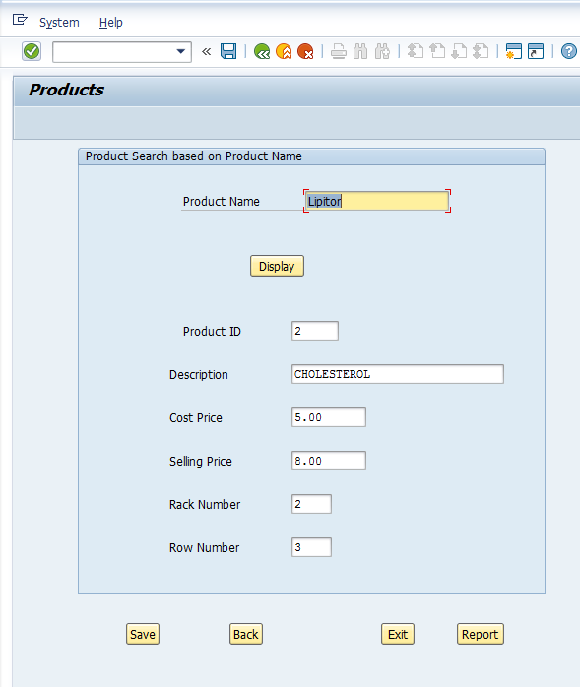

* The only limitation here is, product can be found only using its full name.
* Clicking “Exit” will completely exit the application.
* Click “Back” to go to the previous screen

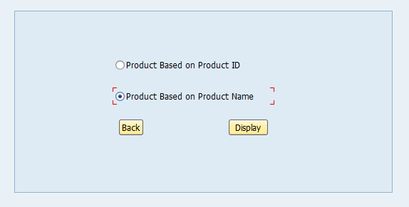

* Click on “Report” button to generate report of all products. This report is same as the one generated in “Product based on Product ID Screen”

